Bright Future

A research study of the working capital that can be released through digital transformation of in-store lighting systems

Zumtobel Global Services (ZGS), 2017

Summary
Retailers are looking to digitally transform their in-store lighting systems, first and foremost in order to save energy and reduce maintenance costs.
However, digital transformation of the lighting system also provides a ready-made network on which to mount sensor-based and data-based technologies that are fundamental to creating the smart store of the future, where the retail environment ‘talks back’ to retail managers, where many tasks can be automated, and where the customer experience can be enhanced and personalised.
At the same time, retail margins remain under heavy pressure. Precious working capital in the retail sector needs to be applied to agile, high return-on-investment, tactical initiatives (promotions, acquisitions, pop-up, etc) and not tied up in depreciating technology assets.
Retailers are therefore increasingly upgrading to digital (LED) lighting platforms through ‘as-a-Service’ financing arrangements, rather than investing capital in those systems. These arrangements, nowadays termed Lighting-as-a-Service (LaaS), use future energy cost savings to pay for the technology upgrade and still deliver – in many cases – net cost savings.
This paper has built a research-based model which demonstrates the very substantial net savings that the retail sector, and selected subsegments, can gain through LaaS arrangements between now and 2025.
Retail Lighting – Disruptive Factors
Lighting in the retail environment is in the midst of two concurrent disruptions. First, LED lighting is rapidly superseding incumbent technologies, as energy-efficiency regulation bites, competition benefits pricing, and retailers seek to use new technology to reduce their energy costs. Secondly, lighting controls systems are greatly extending the capabilities of the technology that operates the lights. In other words, lighting systems infrastructure – which tends to permeate the store, warehouse and back-office environment already – is being seen as the ideal existing network on which to base all the digital enhancements which go to make up smart buildings and smart stores.
A third disruption is financial. Specialist financiers – in particular, those who have an intimate knowledge of the technology and the benefits it delivers in real life – are harnessing the future energy savings and other benefits, in order to finance the digital transformation to an LED in-store environment. In this way, future benefits pay for the system’s digital upgrade. The financier levies a fixed monthly charge over a contract period, meaning that the retailer does not have to commit any precious capital to this digital transformation. And energy savings mean that the retailer is in net credit every month, right from the start of the contract.
Future benefits pay for the system’s digital upgrade

Lighting-as-a-Service Appears
This kind of financing arrangement is becoming known as Lighting as a Service (LaaS). LaaS may be defined as the third-party management of a lighting system that may include additional technical, maintenance, financial, or other services. These offerings can begin with the installation of a lighting system, continue through maintenance and management, and even include upgrade as new products and innovations occur, and/or the recycling or disposal of equipment at the end of its life.
Retailers are realising that this is the beginning of a trend that will mature and grow rapidly over the next 10 years. According to Navigant Research, the size of the global LaaS market is expected to grow from $35.2 million in 2016 to $1.6 billion in 202
Operations directors and facilities professionals are attracted to LaaS as a way of working, because it allows them to procure an agreed set of outcomes, without themselves having to invest in the people, skills and considerable market/technical research to keep on top of emerging technological innovation – something that advances much more swiftly in the modern-day digital environment. Capital commitment and operating risk transfer to the supplier, allowing Operations and Facilities to concentrate on developing strategic skills which lie far more at the core of the value that each department can contribute to the business.

Skills Shortage
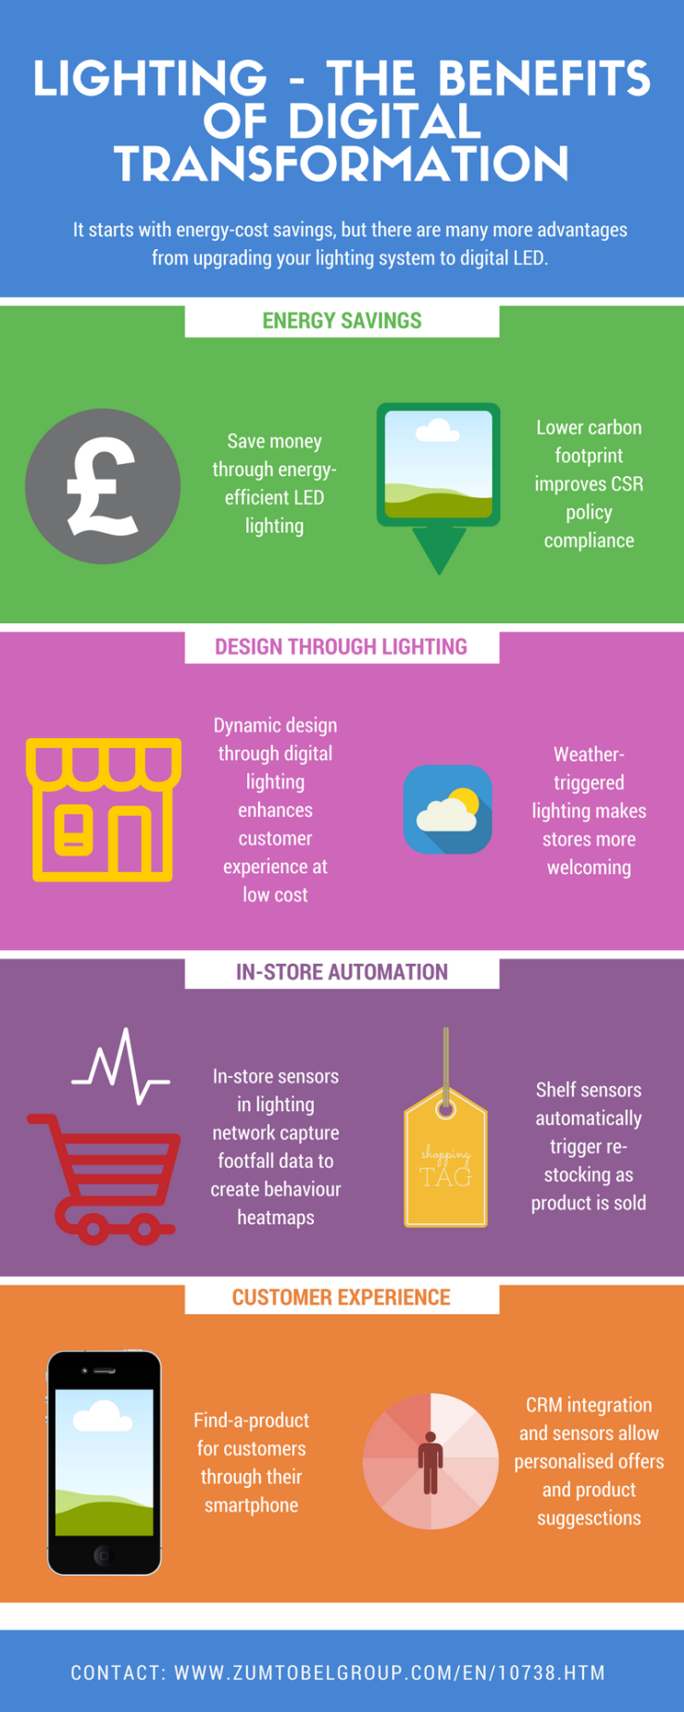
Facilities Management (along with other departments) is facing a skills shortage. At a time when all companies are going through digital transformation of the tech platforms, skilled personnel are hugely in demand. This means that they (a) become difficult to find (b) are difficult to retain and (c) are increasingly expensive. The 2016 Hays Global Skills Index found that Britain’s skills shortage had worsened for the fifth consecutive year.
Looking at the Retail Sector in particular, the Arvato 2015 Outsourcing Index notes, “With new technology driving rapid shifts in consumer behavior, the question for retailers is how they continue to provide a seamless shopping experience across multiple channels. As the research suggests, a growing number of companies are turning to external providers for the technology and expertise required in an increasingly digital market place.” This applies to Facilities Management (FM), IT, Distribution, and other functions of a retail business.
With the emergence of LaaS, retail professionals can concentrate on applying their retail expertise, whereas lighting in-store technology professionals stick to their specialist knowledge, developing smart, sensor-based, in-store solutions based on the lighting network infrastructure.

Lighting as the Smart Store Platform
Since LED lighting is a semiconductor technology, it can act as a platform to deliver a wide variety of intelligent applications and improved functionality with a variety of upgrade options for retailers. In technical terms, there are probably five key capabilities that such smart lighting network infrastructures need to offer:- internet protocol to the endpoint; multi-transport support; distributed intelligence, devolving computing power to allow triggers, actions and decisions by local groups of technology; security standards built on standard protocols to optimize the axis between functionality and security; and a horizontal platform architecture that embraces a multiplicity of devices across applications such as CRM interaction, footfall measurement, smartphone offer triggers, dynamic displays and lighting, and much more.
The rate at which new innovations appear on the market has also become more frequent – often in the form of software or hardware upgrades or new products. This is because digitized systems allow new capabilities to be more easily and inexpensively introduced.

Where LaaS Works Best
The nature of Lighting as a Service (LaaS) means that not every store/store portfolio will be suited to it, although most will benefit. Retail tends to work to the strengths of the model with typically large premises and extended occupancy period, some good examples include; hotels, offices, hospitals, and airports. A minimum scale is required to make sure that return-on-investment (RoI) is commercially feasible. Payback cycles on projects are likely be in the region of 3 to 7 years, but this can embrace technology upgrade points so that retailers can benefit from new innovations that might provide critical competitive advantage in what is a fiercely fought-over market.
Through real time analytics of lighting use, energy consumption, and equipment health monitoring, the pay as you use model can be delivered; negating capital expenditure, technical risk and ongoing maintenance costs.

Conserving Capital for High Return-on-Investment
Cash-on-hand and Net Working Capital in corporations has reached a plateau at around 11-12% of revenues since 2012. This means that overall, available working capital for upgrade to new low-energy lighting environments has not increased over the last few years. At the same time, these figures mask a polarization in the corporate liquidity scene. Highly rated companies can obtain capital at very good rates; conversely, companies in pressurized sectors are finding it less easy to raise capital, and are having to offer more collateral against those loans. The retail sector is under pressure from e-Commerce and property costs, with possibly a future downward Brexit effect on consumer spending. In other words, as a sector, Retail has more challenges in managing its working capital to best effect.
There is great pressure to invest capital in growth-generating activity, rather than depreciating in-store technology assets such as lighting.
All of this means that where a retailer can raise capital, they will be under great pressure to invest that capital in growth-generating activity (sales, marketing, acquisitions, etc) rather than depreciating in-store technology assets such as lighting. All the more reason to enter into a Lighting-as-a-Service agreement where no capital needs to be deployed.
While future technology developments on the lighting network infrastructure offer exciting prospects, Finance Directors (FDs) and Chief Financial Officers (CFOs) will tend to concentrate on energy cost savings that digital transformation enables. This is where the fundamental financial rationale for return on investment comes from. It is also the key to freeing up working capital by making a transition to Lighting as a Service.
Net Energy Savings – the Size of the Prize
In order to give readers an idea of the sums which can be liberated for other purposes through LaaS financing arrangements, Zumtobel Global Services (ZGS) commissioned independent research to estimate the ‘size of the prize’ in UK Retail.
The research examined multiple examples of pioneering retail LaaS examples in order to derive a net savings average per m² for the UK retail environment. This average has then been applied to the UK retail estate, with certain provisos – as flows. The savings figure per m² includes the cost of digital technology transformation incorporated into a monthly LaaS charge, and therefore represents the net savings that the industry could reap over a financing period. Other studies have estimated gross energy savings, but this does not represent a commercially realisable sum for the retail industry. This study also takes into account the current penetration of LED technology into the population of lighting installation in UK retail. In other words, the model used in this study has made every effort to be as conservative as possible, painting a commercially realistic picture of the net financial sums that could be released through digital lighting transformation.
Net cost savings 2017-2025 from transformation to digital, energy-efficient lighting
 | £ million
UK Retail – Total | £6,296
UK Shopping Centres | £790
UK Retail Parks | £494
The sums revealed by this ZGS research are considerable, offering the sector an opportunity to make savings at a scale that should be on the radar of senior management. LaaS arrangements, which are already in place with a significant minority of pioneer retailers, allow future cost savings to be harnessed to pay for today’s digital technology upgrade. But it is the idea of using the existing lighting infrastructure as the framework, network and transport system for sensor-based digital smart stores, that elevates digital transformation to a higher strategic plane. No other physical in-store network permeates the retail environment like the lighting infrastructure, which means digital expansion and re-purposing should deliver the highest return on investment.

Conclusions
Many industries are going through their version of digital transformation. Many are looking to use energy cost savings to at least subsidize, if not completely pay for, that transformation. Doing nothing is not an option, unless an organisation wants to deliberately set itself at a disadvantage versus competitors. In all cases, making the digital upgrade is both compelling need, but also a financial challenge. Financial agility is increasingly prized in a digital, more volatile world, and that tends to make firms reluctant to tie up precious capital in depreciating technology assets. Lighting-as-a-Service arrangements are becoming so popular precisely because they enable investment without capital commitment, moving the business model from buying technology, to paying for access to that technology.
It is the combination of smart financing and smart technology that is accelerating investment in the smart store. Once a LaaS arrangement is in place, net savings go straight into the pressurised bottom line, and the first steps to smart store development are under way.

Financial Times, Survey underlines engineering and tech skills gap, 21 Sept 2016
See, for instance, Automation World, Break the Replacement Cycle, 14 June 2016
See, for instance, Siemens, Outcomes & Opportunities, March 2017
PwC, 2016 Annual Working Capital Opportunity – Liquidity Availability

